Flow Chart on Patent Registration System

Filing of PT-1

Notification (PT-C) to submit corrections

Receipt and minimum check to accord filing
OK

Not OK

Non-compliance to PT-C.

Submission of corrections vide PT-2.
Notification(PT-B) of filing date

Notification(PT-D) that PT-1 deemed not filed.

Formality Examination
Not OK
OK
Notification (PT-E) to submit corrections

Submission of corrections vide PT-3
Non-compliance to PT-E or corrections submitted are incompliance.

Notification(PT-F ) of Rejection.

Notification(PT-G) Submission of PT-3A
Appeal to Court/Registra

Substantive Search and Examination

Review of Substantive Report
OK
Notification (PT-H) to submit corrections

Court decision
Not OK

Non-compliance to PT-E or corrections submitted are incompliance
Submission of PT-4
Notification(PT-J) to submit grant & publication fee.
Submission of corrections vide PT-3

Ok

Reinstate ment of PT-1
Patent certificate
Grant and Publication
Notification(PT-I) of refusal

Not Ok

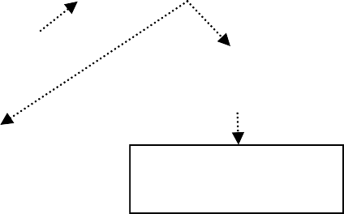
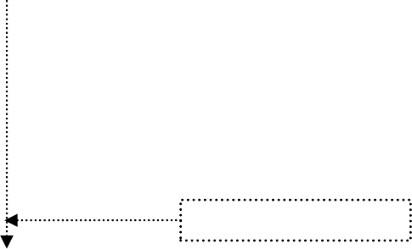
20 Years
No reinstatement of PT-1

Submission of Annual maintenance Fee(PT-5)

Expiry of Patent

